
Stay-All-Day Activity (MS/HS) – Organizer Notes

Two-Point Discrimination

Description: An experimental design activity that involves pairs of students gently poking different body parts to determine their two-point discrimination thresholds,collecting data and answering experimental questions. This activity requires very few materials. Non-competitive.

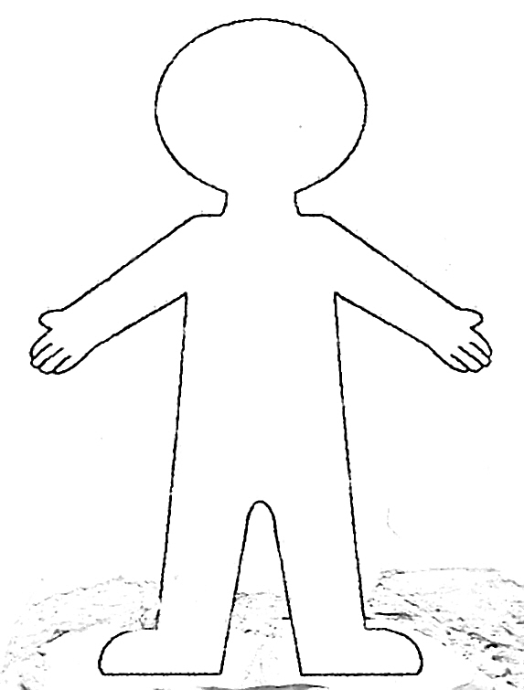
If a team has an odd number of members, the coach could pair up with one of the students.

Materials: A rough cutout of a human body, as shown to the right, posted on a wall. It should be large enough for students to add sticky notes in various locations without too much crowding.
Per pair: 1 metric ruler, 1 paper clip, 1 chair, 8 sticky notes, 1 copy of the student handout (copied back to back and stapled)

Experimental Design Section: Read over the entire activity with the participants before allowing them to start. Then they can loop back and answer the questions in the experimental design section. The hypothesis is not written in the typical “If independent variable then dependent variable because…” fashion that is commonly taught in schools, but it is similar. Students will complete the given hypothesis by circling one of two choices of dependent variable and providing an explanation for their choice.

The independent variable is the body part and the dependent variable is the two-point threshold. The control trial should be a specific finger (most likely an index finger), but students should choose what they think is best. Constants could include closed eyes, same pressure of poking, same duration of poking, and other factors. The experimental trials could be any body part that is accessible and appropriate: back of the neck, top of the foot, bottom of the foot, etc.

Data Analysis: According to Eric Brunsell, Assistant Professor of Science Education at UW-Oshkosh, a claim is something you know. Evidence is how we know what we know (a subset of the data). Reasoning explains why the evidence supports the claim. http://www.edutopia.org/blog/science-inquiry-claim-evidence-reasoning-eric-brunsell

There is no right or wrong answer for the claim; it depends on how students interpret the evidence from the data they collected. They should not, however, find that all parts of the body are equally innervated with sensory nerves.

This activity is non-competitive. You may choose to have the students present their conclusions aloud at the end and debate why there may be different findings. Ask them to predict the most innervated locations on a dog or another animal. The paper human and written conclusions can be displayed in a common area.

The U.S. Department of Energy Office of Science manages the National Science Bowl®, and sponsors the NSB finals competition. DOE’s Office of Science is the single largest supporter of basic research in the physical sciences in the United States, and is working to address some of the most pressing challenges of our time. For more information, please visit http://science.energy.gov/.

Stay-All-Day Activity (HS) – Student Handout

Two-Point Discrimination

Background: The two-point discrimination test has been used in medicine to assess tactile gnosis, the ability to perceive and recognize an object without visual or auditory cues. It is also used to assess recovery after damage to peripheral nerves (nerves that are outside of the brain and spinal cord).

Your Task: Design an experiment to determine the two-point discrimination threshold on various body parts to answer the experimental questions.

Experimental Questions: Are all parts of the body equally innervated with sensory nerves? Would different parts of the body have the same or different two point discrimination threshold? Do most people show the same pattern?

Hypothesis: Different areas of the body will have the same/different (circle your choice) two-point discrimination threshold because (provide an explanation for your hypothesis)
___________________________________________________________________

__________________________________________________________________.

Independent Variable: ______________________________

Dependent Variable: ______________________________

Control Trial: ______________________________ (Think about which part of the body is often used for sensing the environment through touch.)

Constants: _________________________________________________________
(Choose 3 or more factors that you will not change between trials.)

Experimental Trials: __________________________________________________________________
(Choose 3 or more other body parts that are not usually used to sense the environment through touch.)
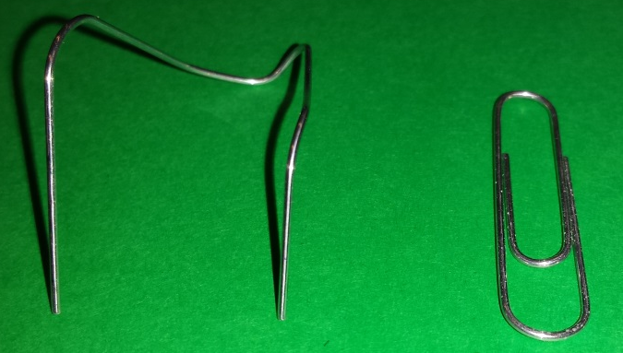
Materials: Per pair: 1 metric ruler,
1 paper clip, 1 chair, 8 sticky notes

Procedure:

- Bend the paper clip as shown in the photo above.
- Sit in a chair and close your eyes. Your partner will touch the paperclip to the control body location. It is important to touch the skin with the two ends of the paper clip simultaneously with the same pressure. Tell your partner how many points of the paper clip you can feel.
- If you feel 2 points, have your partner move the ends of the paperclip closer together and repeat the procedure. If you feel 1 point, have your partner increase the distance between the ends slightly and repeat the procedure.
- Continue this until you find the distance between the points that always gives the sensation of having 2 points touch the control location, but if this distance is reduced, it only feels like a single point. This is the TWO- POINT discrimination threshold.
- Use the metric ruler to measure the paperclip distance and record the two-point discrimination threshold in millimeters.
- Repeat the experiment to determine the two-point discrimination threshold for the experimental trial locations your group has chosen.
- Switch roles with your partner and repeat.
- Repeat for a 2nd trial on each person if time permits.
- Display your results on sticky notes posted to the appropriate test locations on the paper body on the wall. Use average values if you were able to test more than once. Note how your results compare to those of other teams.

Upon completion, turn in your written work to the activity organizer.
Good work, and thanks for Staying-All-Day!

Data: Team name______________________________________

Two-Point Discrimination Test – Person’s name___________________
 | Two-Point Discrimination Threshold Distance (mm)
Body Location | Trial 1 | Trial 2

Two-Point Discrimination Test – Person’s name___________________
 | Two-Point Discrimination Threshold Distance (mm)
Body Location | Trial 1 | Trial 2

Data Analysis:
Compare the data for all of team members. Was your hypothesis supported or refuted? Make a claim about the two-point threshold and the use of the body part in tactile sensing of the environment. Support your claim with evidence.

